**Overview:**

* Project Title: *Inventory Management System.*
* Tools Used: IDE, Junit5,mockito-core,sqlite-jdbc.
* Purpose: This document includes 5 mutants created from the source code and their corresponding test results to demonstrate the effectiveness of the unit tests through mutation testing.

Original methods:

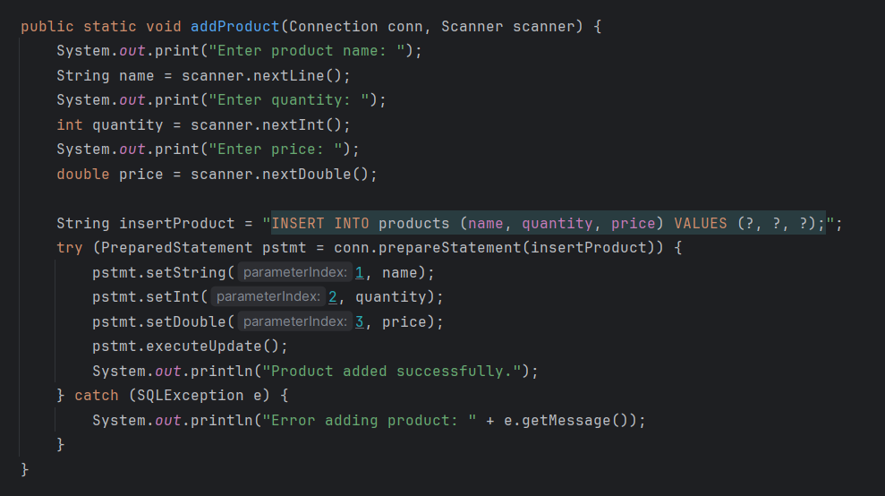

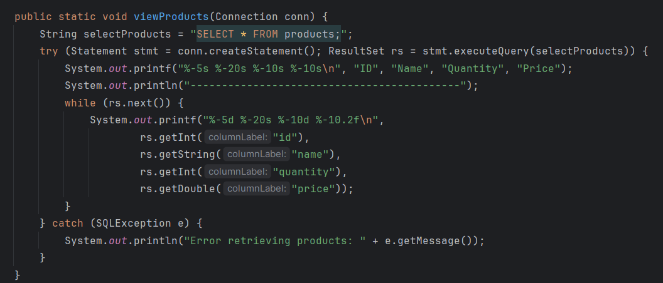

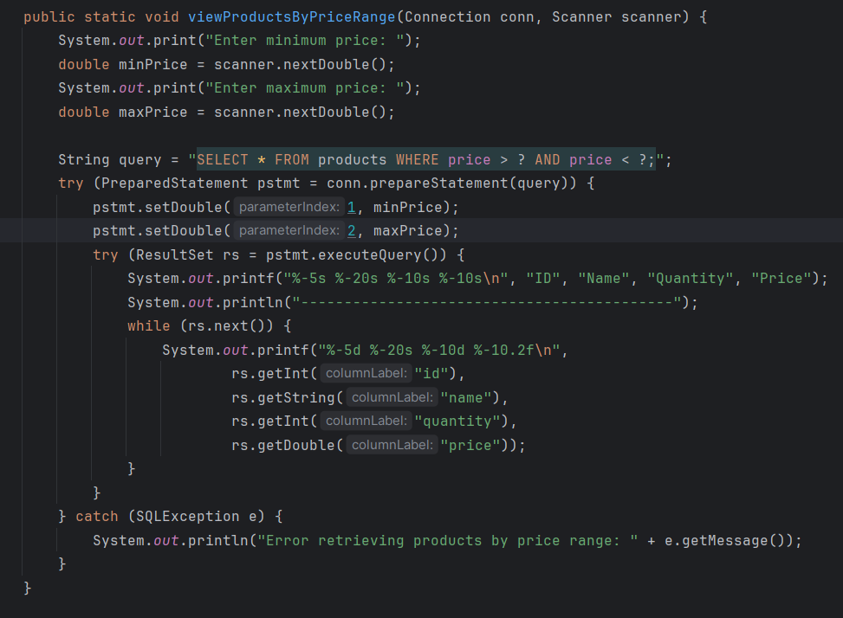

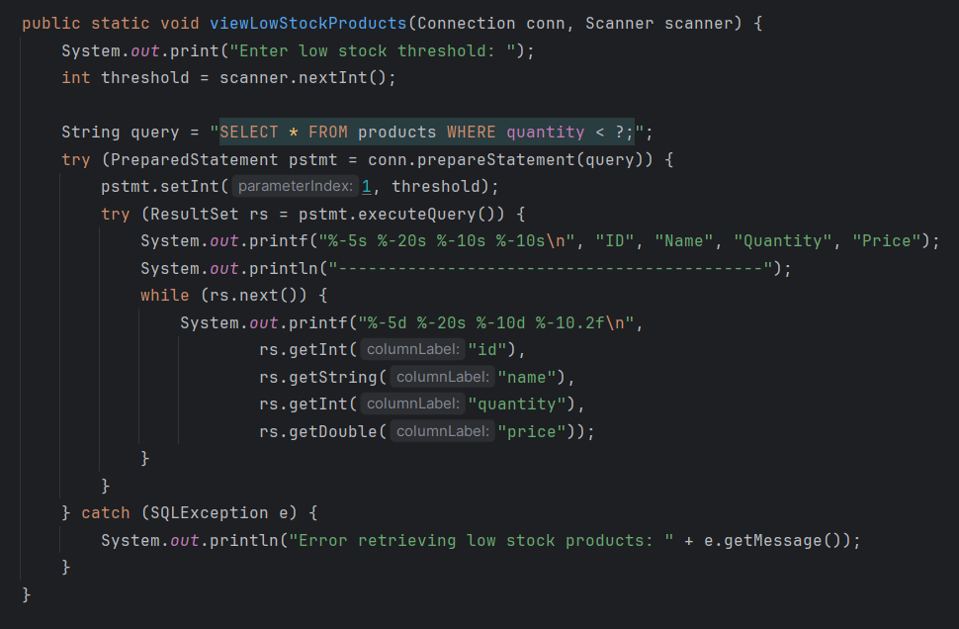

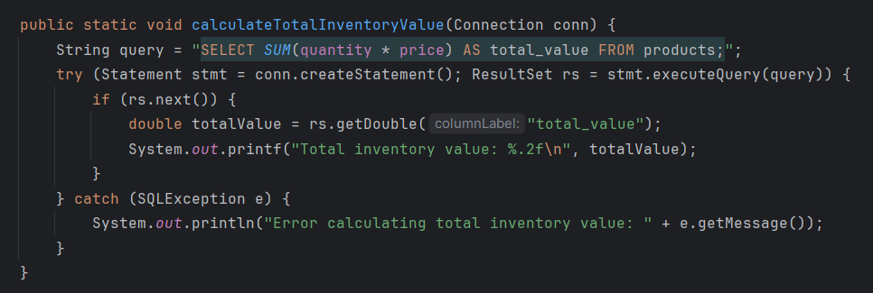

| Mutant ID | Mutation Type | Mutated Code Snippet | Expected Result | Actual Result | Killed? |
| --- | --- | --- | --- | --- | --- |
| M1 | Variable Replacement | "INSERT INTO products (caled, quantity, price) VALUES (?, ?, ?);"instead of "INSERT INTO products (name, quantity, price) VALUES (?, ?, ?);" | Test failed | Test failed | Yes |
| M2 | Variable Replacement | "SELECT id FROM products;"instead of "SELECT * FROM products;" | Test failed | Test failed | Yes |
| M3 | Relational Operator | WHERE price >= ? AND price <= ? Instead of WHERE price > ? AND price < ? | First ans last product shouldn’t view | Test passed | No |
| M4 | Relational Operator | WHERE quantity <= ? instead of WHERE quantity < ? | test should fail | Test passed | No |
| M5 | Arithmetic Operator Replacement | SUM(quantity + price) instead of SUM(quantity * price) | test should fail | Test passed | No |

### ****Analysis****:

* **Total Mutants**: 5
* **Mutants Killed**: 2
* **Mutation Score** = (2 / 5) × 100 = 40%